Area Under a Curve - Intro

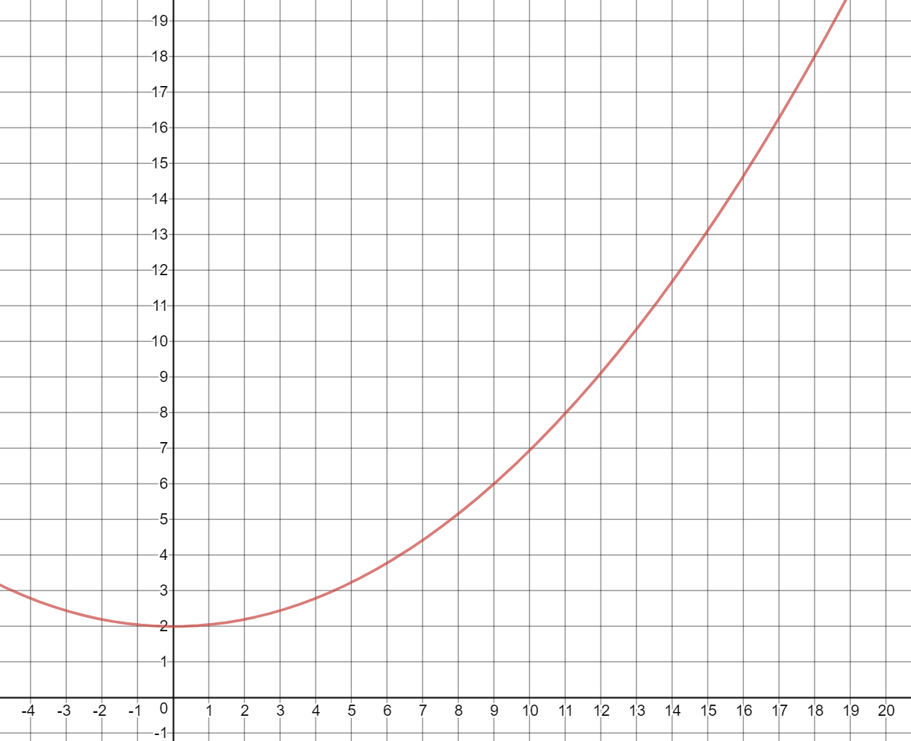

Discuss:

1. Approximate the area under f(x) and above the x-axis between x=4 and x=14.

2. Approximate the same area as above using 5 rectangles of equal width.

Area Under a Curve - Intro



Discuss:

1. Approximate the area under f(x) and above the x-axis between x=4 and x=14.

2. Approximate the same area as above using 5 rectangles of equal width.